Create a java class to hold the salesman data, call it the SalesPerson class. The fields for this class arename, city, commission, and totalSales (for total of sales by this salesPerson). Also provide a constructor and a toString() method (this was part of last week’s exercises)
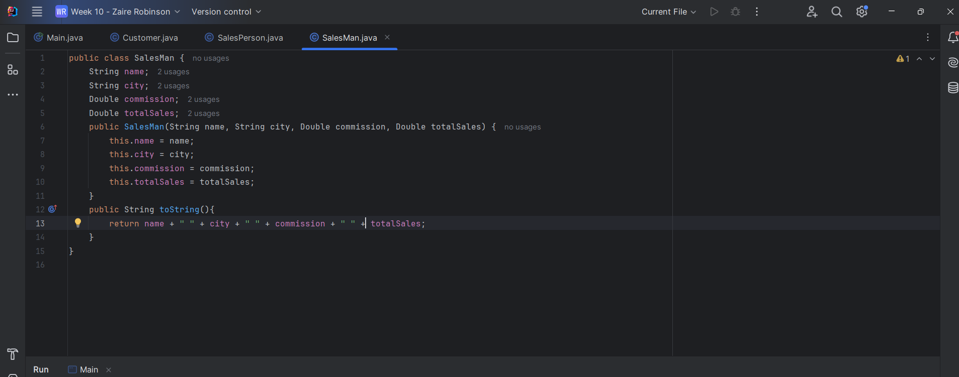
Then from the result of the SQL query, create SalesPerson objects and put them in an ArrayList<SalesPerson> called salesPersonList.
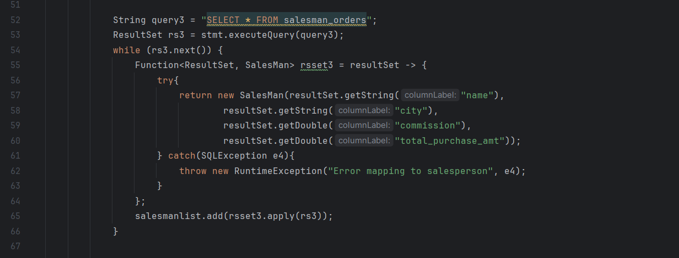
1. Print all salesPersons names and their total earnings in a neatly formatted table.
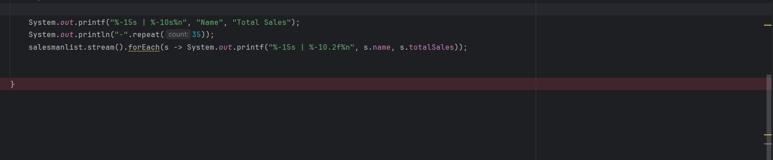
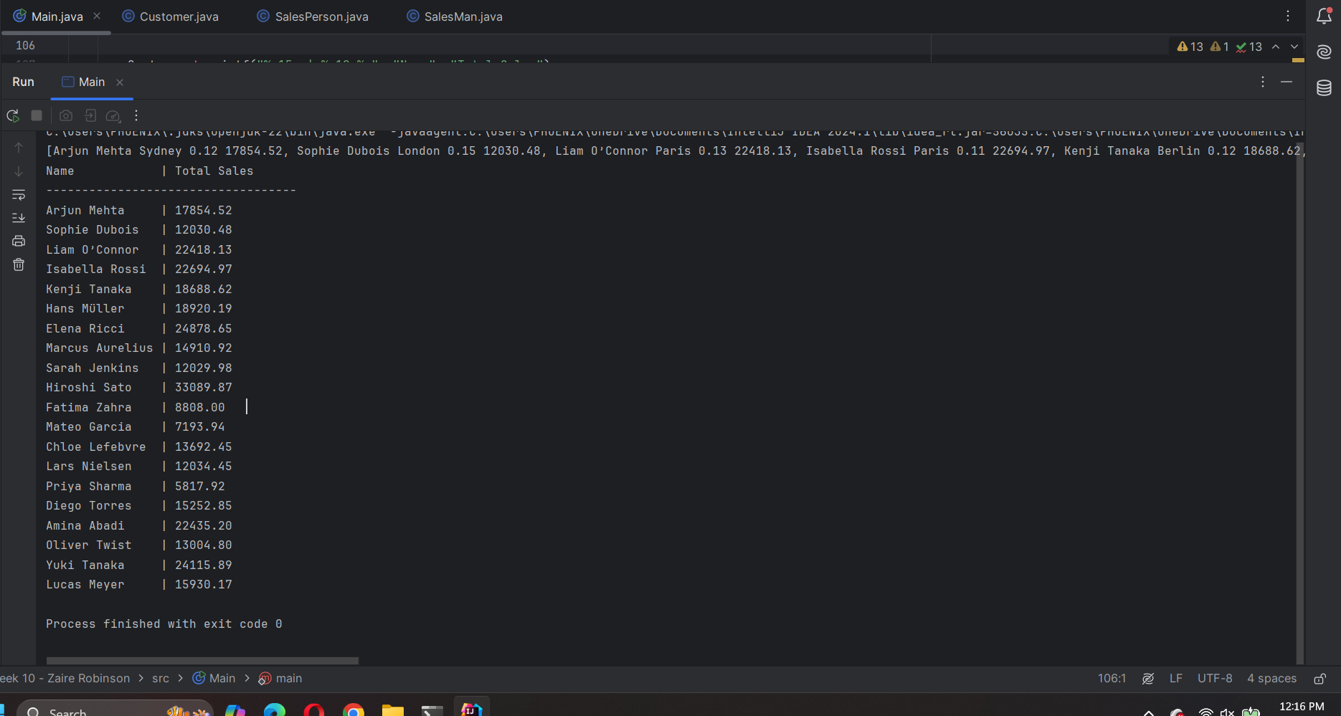
2. Print all salesPersons names and their total commissions in a neatly formatted table.
